Analytical concepts PTED proposal

# Dimensions of representing movement

## Properties of the movement spaces

1.1 Continuous vs. discrete movement spaces

1.2. Conceptual Models vs. data structures

– Field-based (A.2): DEM – Entity-based (A.3): Lakes vs. forests

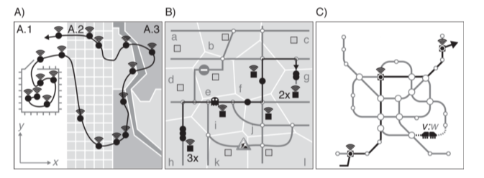– Network space (B, C)

1.3. Dimensionality of movement spaces

Vector data, 2D trajectories + time = 3D, x, y, t

## Properties of the movement

2.1. Unconstrained vs limited vs. constrained/restricted

**Constrained**/restricted movement (Strassen, Veloweg, Gleis von Zug, Brücken, ect…)

2.2. Uniform vs. **intermittent**, periodic

2.3. **Active or passive**

Both; bicycle and train

## Perspective of observation

3.1. Lagrangian vs Eulerian perspective

-> **Lagrangian**

3.2. Sampling regime

-> continuous every (posmo 5s, 10s, 15s, gps tracker?)

3.3. **Active** vs. passive tracking

3.4. Off-line vs. **real-time**

3.5. Obfuscation for safeguarding privacy – **maybe?**

## Semantic level of interest

4.1. Fix (A)

4.2. Vector (B)

4.3. Move (C)

**4.4. Segment (D)**

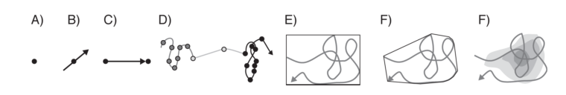4.5. Areal aggregations (F)

# Data issues in environmental data analysis

1. Measurement error

2. **Outliers** -> can be visually excluded (relevant for our study question)

3. **Artifacts** -> can be excluded by processing with segments (relevant for our study questsion)

4. Choosing a method

Problem: low precision, not so much a problem: low accuracy

**Scale and granularity**? -> set with the sampling frequency, it might be even **too fine scale for our research question**

* Sampling means choosing a scale

# Sampling movement parameters

• Operations derive movement parameters

– Attribute-operations with entities

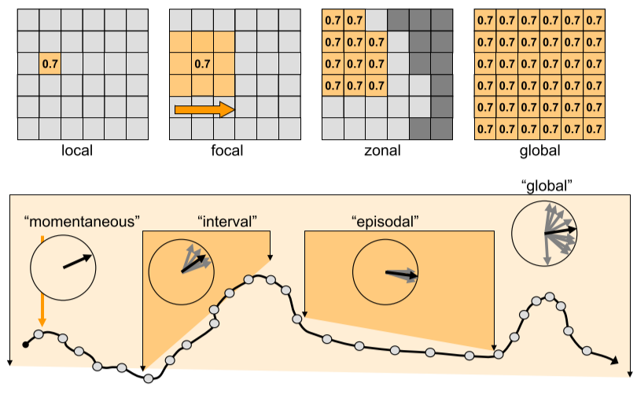 – map algebra with fields

• Important movement parameters in CMA:

– Speed [v]

– Acceleration [a]

– Azimuth [azi]

– Sinuosity [s]

• Movement parameters are key to

– Assessing trajectory similarity

– Clustering trajectories

* 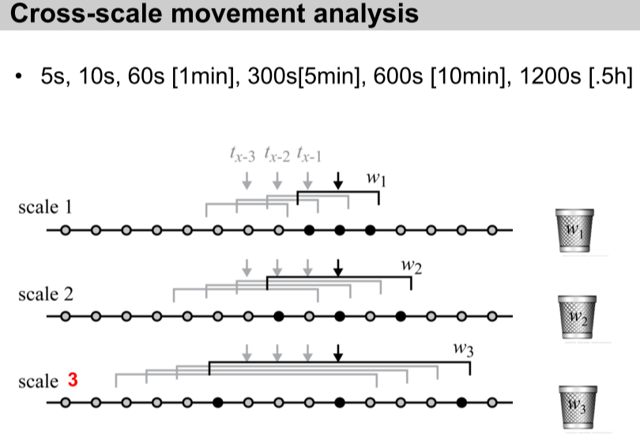Sampling means choosing a scale

# Segmentation

## – Stops and moves

Stationary vs moving

## – Semantic annotation

# Similarity

## – Why compute trajectory similarity?

To find similar patterns, habits and for clustering

Procedure for assessing trajectory similarity and subsequent trajectory clustering   
• Specify a frame of reference. What shall be compared? The entire lifeline of an object?  
• Choose or define a distance metric.   
• Compute similarity matrix and apply a suitable clustering technique.

## – Why is it difficult?

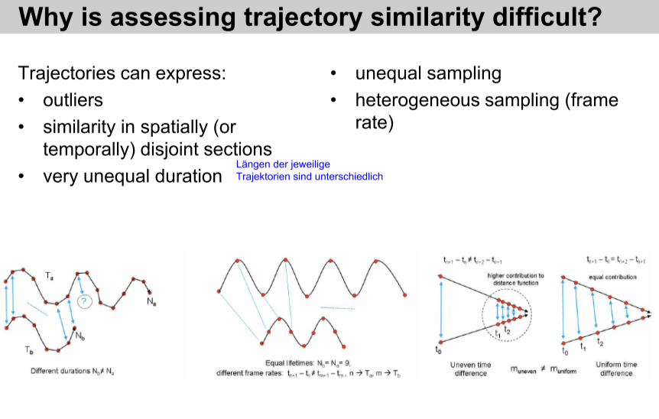

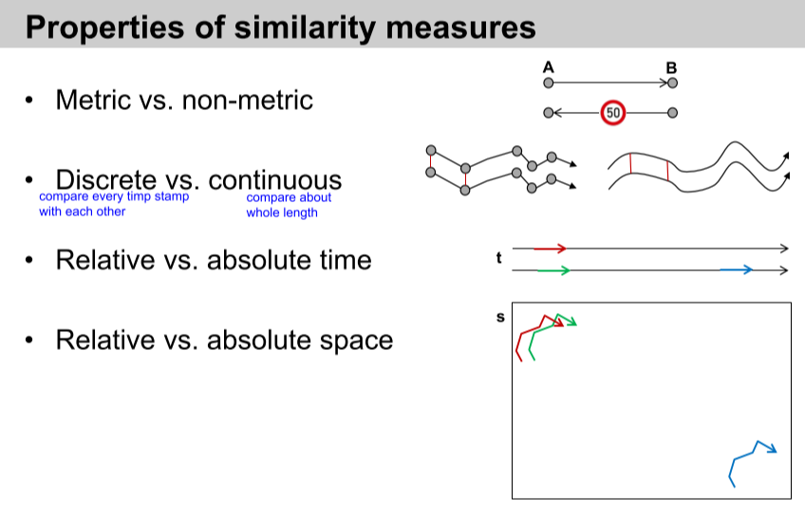

## Analytical concepts (Miri)

<!-- Which analytical concepts will you use? What conceptual movement spaces and respective modelling approaches of trajectories will you be using? What additional spatial analysis methods will you be using? -->

My Text:

Our movement data is tracked in a continuous movement space (the whole earth surface) and the best suitable conceptual model is probably a network space combined with an entity-based model. Our data structure is vector based so that we can obtain trajectories in a two-dimensional space where movement can be constrained by objects (e.g., houses) and movement corridors like streets and train tracks. The movement takes place in an intermittent manner and can be active (by foot) or passive (by train, boat). As all students have been tracked actively and in real-time by the posmo app (every 5s, 10s, or 15s) or by a GPS tracker, the perspective is Lagranian with a continuous sampling regime.

Based on our research questions we are mainly interested in the average travelling distances of the students. Therefore, our semantic level of interest concerns only segments. As a first step, the raw data must be inspected and pre-processed. We will start by getting an overview of our data by visualizing it in different ways and thereby also detect possible measurement errors, gaps and outliers that can be excluded as a next step. A map matching will help to detect low GPS accuracy or precision, where for this study the ladder is more relevant and could have a high impact on our results. {Operations derive movement parameters (attribute-operations with entities or map algebra with fields) -> anything of this needed in our analysis?}

We might also calculate the sinuosity [s] as the chance of underestimating average travelling distance gets higher, the finer scale our data is in combination with a high sinuosity. The sinuosity measure in addition to a cross-scale movement analysis will help finding the suitable scale and granularity to calculate travelling distances.

Once the pre-processing is done, we can proceed to computing our trajectory segments in the following four steps: a) specify a temporal window v, b) measure the distance from every point to every other point within this temporal window v, c) define a distance threshold between points below which the movement is defined as “static” and remove all static points and d) assign all segments with an individual ID. As a next step we might include a similarity measure between all trajectories to be able to detect possible patterns derived by effects of university affiliations, holidays, and weather conditions. Furthermore, possible artifacts will be excluded by processing with segments.

As a last step, the length of all segments of a trajectory needs to be added up as a baseline for further comparison of average travelling distances and their dependences on other factors like weather condition. By filtering the dataset, average travelling distances per factor (for example student and weekday) can be calculated. To find possible effects of the weather condition on average travelling distances, the weather data must be categorized, so that comparisons of average travelling distances per weather category can be made.

{- Operations derive movement parameters (attribute-operations with entities or map algebra with fields)   
- Rolling window functions}

## Abstract (Miri)  
<!-- (50-60 words) -->

For every living being, movement is coupled with an individual energy cost. Throughout anthropogenic development, this energy cost could be reduced more and more by increasing movement efficiency. Today, in the face of climate change, movement efficiency is still a topical issue. To reduce energy cost of movement and increase its efficiency, it applies to reduce the travelling distance between two points to an absolute minimum. In this study, we will therefore address movement efficiency by investigating the effects of environmental factors (e.g., weather condition, influence of holiday, university affiliation) on average travelling distance of students, with the aim to reveal factors that prevent students from minimizing their movement costs.

Quellen Abstract:

Goossens, S., Wybouw, N., Van Leeuwen, T., & Bonte, D. (2020). The physiology of movement. *Movement Ecology*, *8*, 1-13.

Halsey, L. G. (2016). Terrestrial movement energetics: current knowledge and its application to the optimising animal. *Journal of Experimental Biology*, *219*(10), 1424-1431.

Jaffe, A. B., Newell, R. G., & Stavins, R. N. (1999). Energy-efficient technologies and climate change policies: issues and evidence. *Available at SSRN 198829*.

In this study, we will address movement efficiency by investigating the effects of environmental factors (e.g., weather condition, influence of holiday, university affiliation) on average travelling distance of students, with the aim to reveal spatial and temporal patterns.